HOLDEN EVENING PRAYER
Prelude
Welcome and Announcements
Silence
Confession and Forgiveness
P: Let us confess our sin in the presence of God and of one another.
Most holy and merciful God,
C: We confess to you and to one another, and before the whole company of heaven, that we have sinned by our fault, our own fault, by our own most grievous fault, in thought, word, and deed, by what we have done and by what we have left undone.
P: We have not loved you with our whole heart, and mind, and strength. We have not loved our neighbors as ourselves. We have not forgiven others as we have been forgiven.
C: Have mercy on us, O God.
P: We have shut our ears to your call to serve as Christ served us. We have not been true to the mind of Christ. We have grieved your Holy Spirit.
C: Have mercy on us, O God.
P: Our past unfaithfulness, the pride, envy, hypocrisy, and apathy that have infected our lives, we confess to you.
C: Have mercy on us, O God.
P: Our self-indulgent appetites and ways, and our exploitation of other people, we confess to you.
C: Have mercy on us, O God.
P: Our negligence in prayer and worship, and our failure to share the faith that is in us, we confess to you.
C: Have mercy on us, O God.
P: Our neglect of human need and suffering, and our indifference to injustice and cruelty, we confess to you.
C: Have mercy on us, O God.
P: Our false judgments, our uncharitable thoughts toward our neighbors, and our prejudice and contempt toward those who differ from us, we confess to you.
C: Have mercy on us, O God.
P: Our waste and pollution of your creation, and our lack of concern for those who come after us, we confess to you.
C: Have mercy on us, O God.
P: Almighty God have mercy on us, forgive us all our sins through our Lord Jesus Christ, strengthen us in all goodness, and by the power of the Holy Spirit keep us in eternal life. C: Amen.

Service of Light
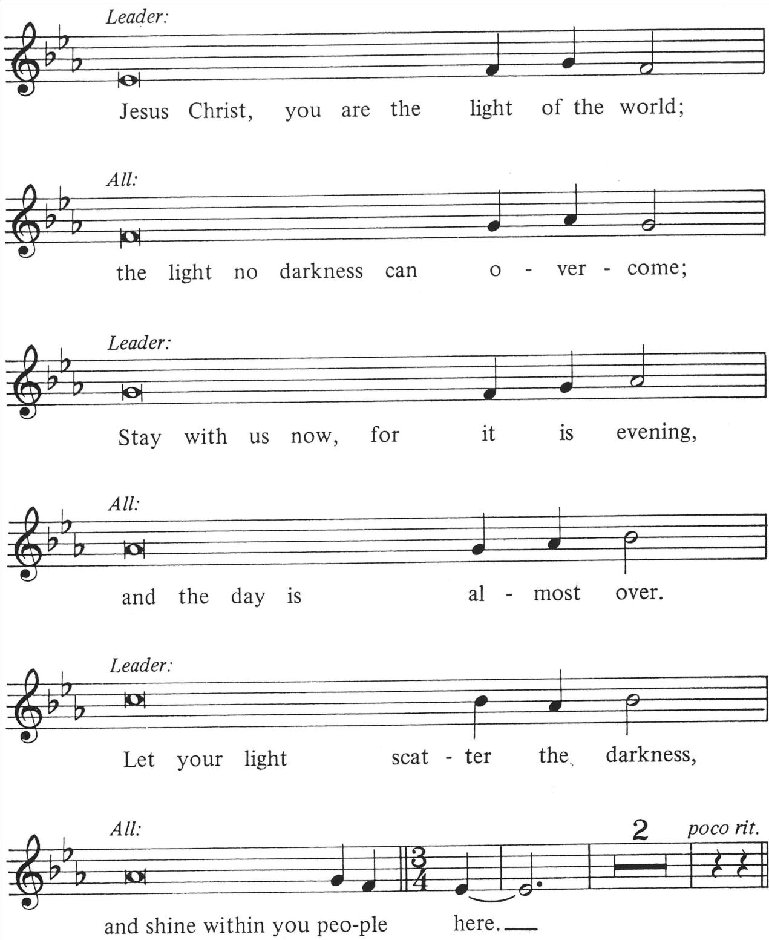

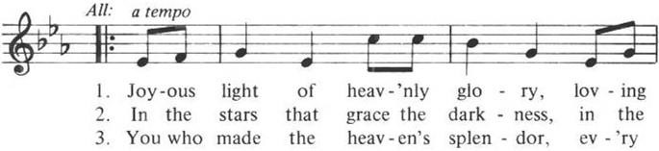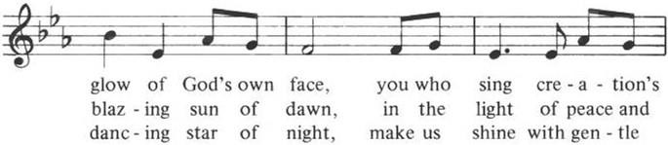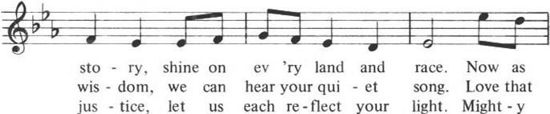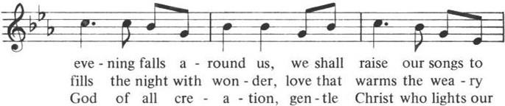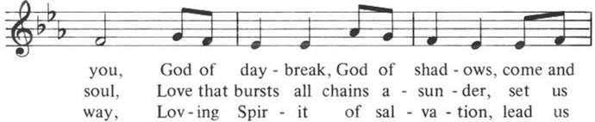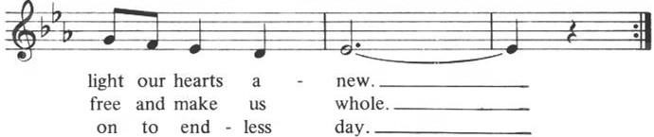

Evening Thanksgiving
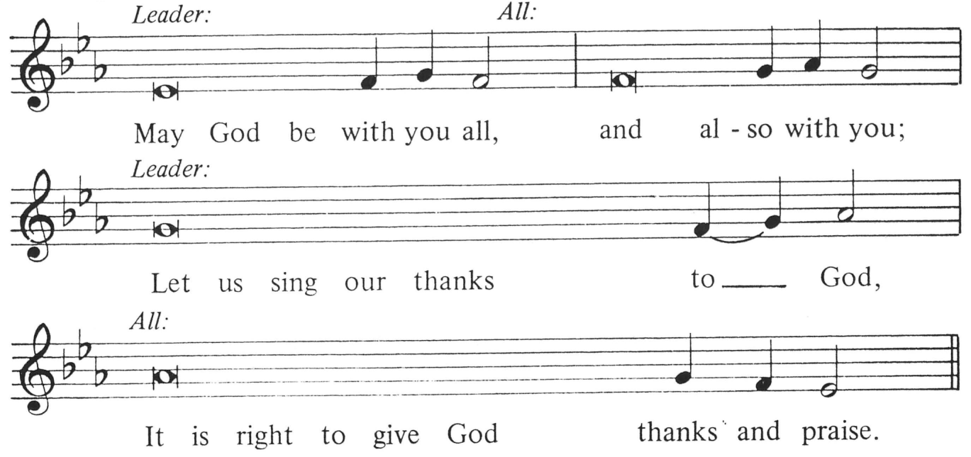

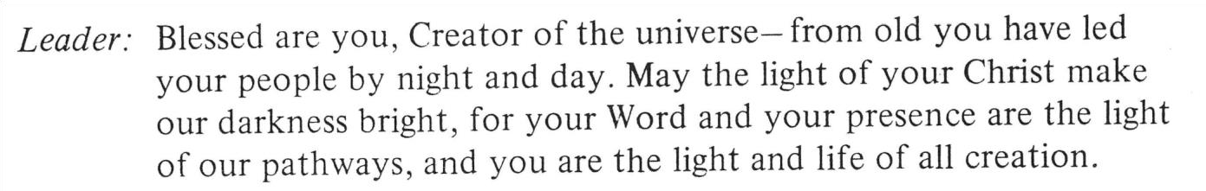

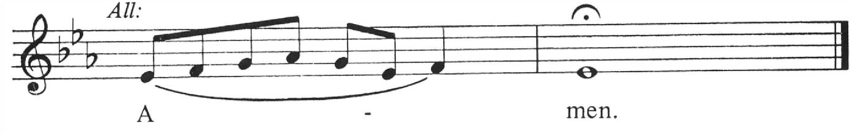

Psalmody Psalm 141
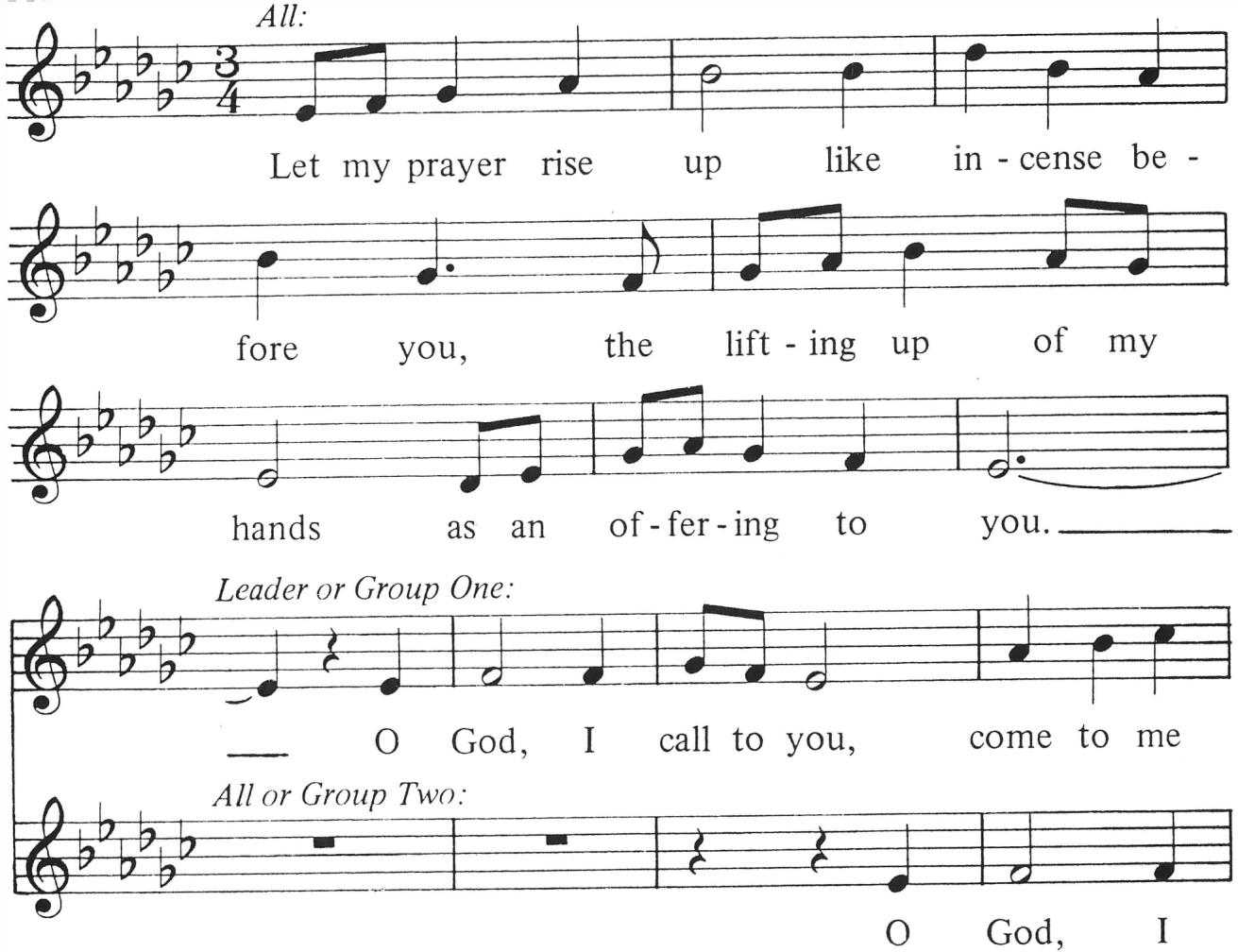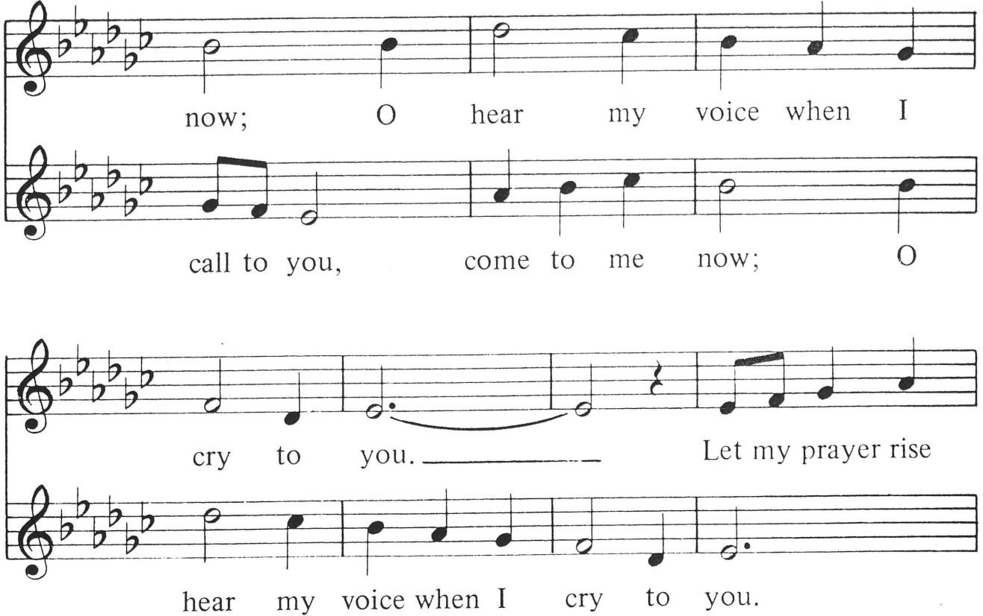
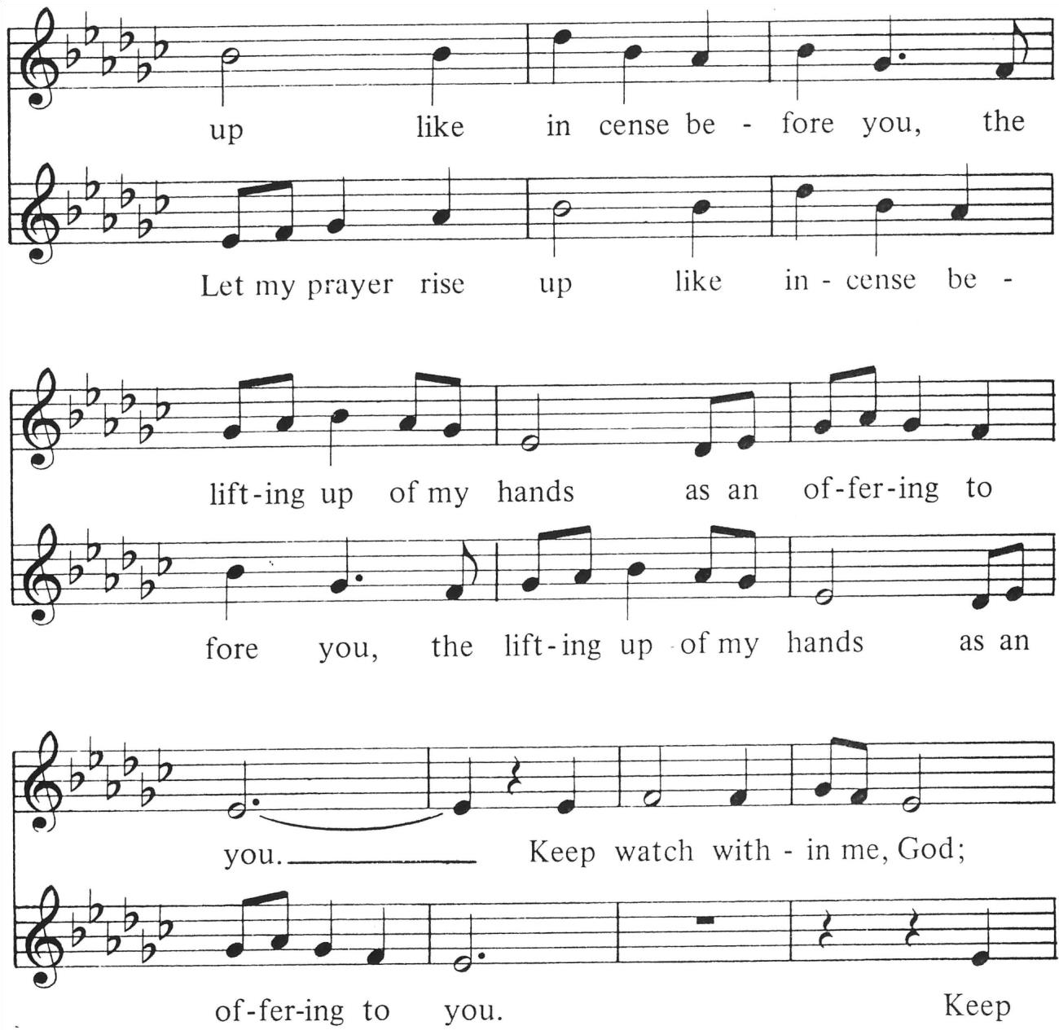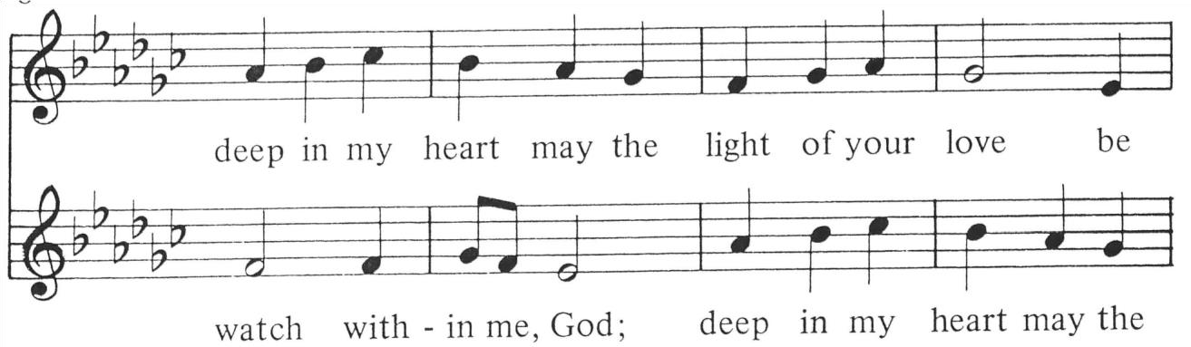
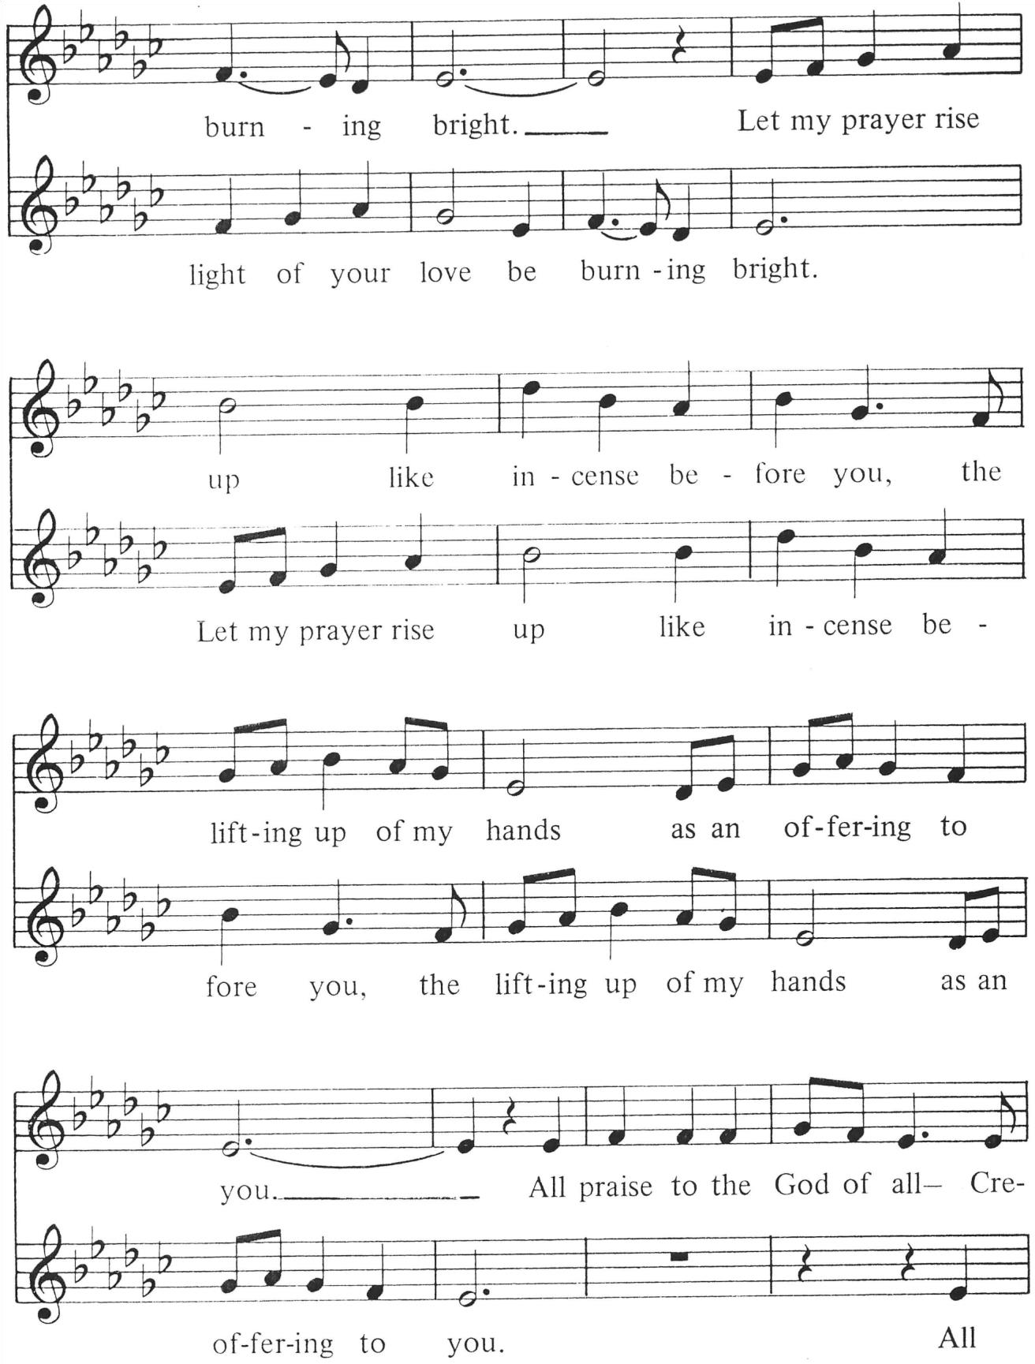

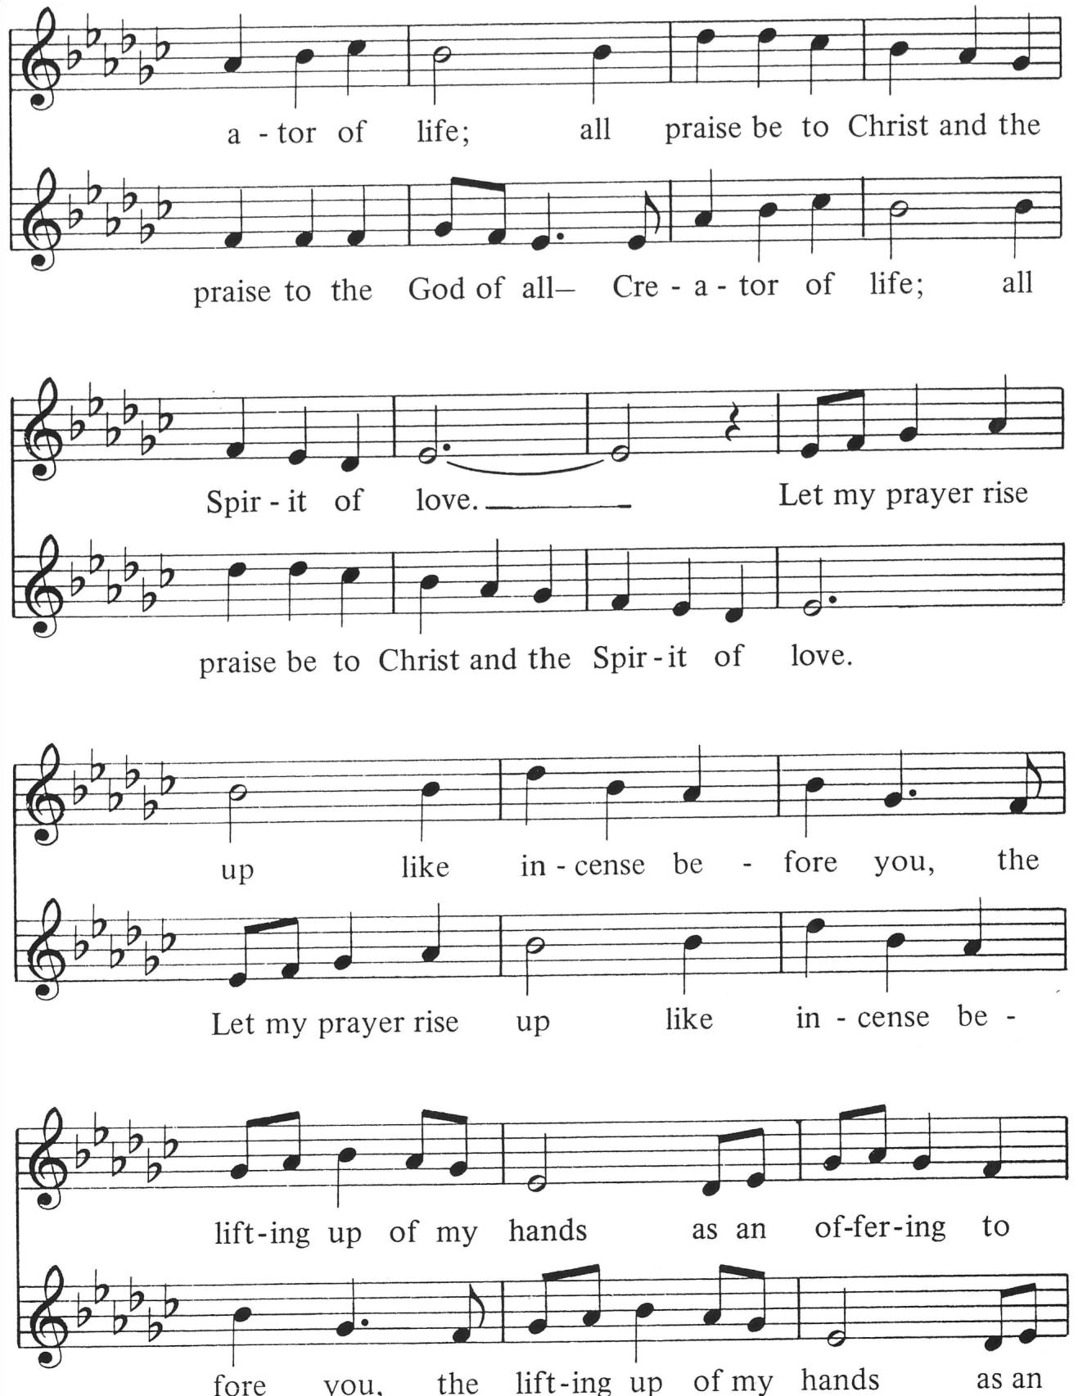

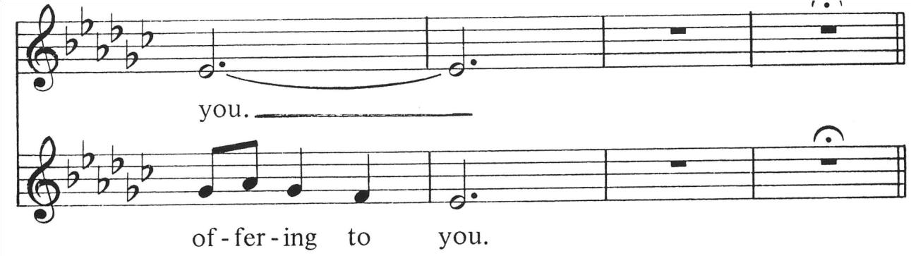

Silence
☹ May our prayers come before you, O God, as incense, and may your presence surround and fill us, so that in union with all creation, we might sing your praise and your love in our lives.
 Amen.
Sermon
March 9: “The Woman at the Well” John 4:1-42
March 16: “Peter, the Rock?” John 1:35-42
March 23: “Mary Magdalene: A Woman Released and Redeemed”
Luke 8:1-3, Mark 15:33-41, Mark 16:1-11
March 30: “Paul, the Apostle” Acts 7:51-60, Acts 9:1-22, Romans 3:21-28
April 6: “Mary, the Mother of Jesus”
Luke 2:25-38, Luke 2:41-52, John 2:1-11, Matthew 13:53-58

Hymns Will be sent to you weekly
March 9: “In the Cross of Christ I Glory” (Vss. 1, 2, 4) ELW 324
March 16 : “Alas! And Did My Savior Bleed” (Vss. 1, 2, 4) ELW 337
March 23: “Beneath the Cross of Jesus” (Vss. 1, 2, 3) ELW 338
March 30: “Ah, Holy Jesus” (Vss. 1, 2, 3, 4, 5) ELW 349
April 6: “O Sacred Head, Now Wounded” (Vss. 1, 2, 3, 4) ELW 351

The Apostles’ Creed
I believe in God, the Father almighty, maker of
heaven and earth.
I believe in Jesus Christ, God’s only Son, our Lord.
who was conceived by the Holy Spirit, born of the virgin Mary, suffered under Pontius Pilate, was crucified, died, and was buried; he descended into hell.
On the third day he rose again.
he ascended into heaven, he is seated at the right hand of the Father, he will come again to judge the living and the dead. I believe in the Holy Spirit, the holy catholic Church, the communion of saints, the forgiveness of sins, the resurrection of the body, and the life everlasting.
Amen

L The light shines in the darkness
X and the darkness has not overcome it.

The Annunciation Luke 1:26-28, 30-32, 38
☹ An angel went from God to a town called Nazareth to a woman whose name was Mary. The angel said to her, “Rejoice, O highly favored, for God is with you. You shall bear a child, and his name shall be Jesus, the chosen One of God Most High.” And Mary said, “I am the servant of my God, I live to do your will.”

Magnificat Luke 1:46-55
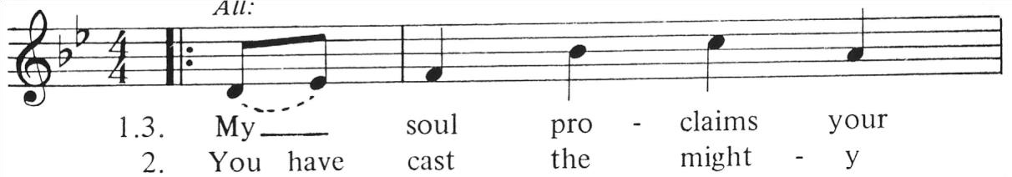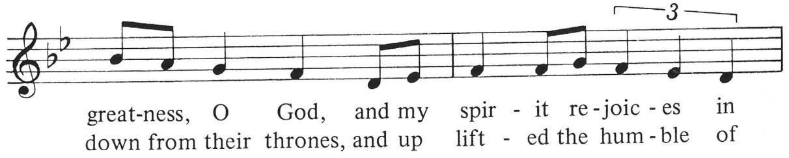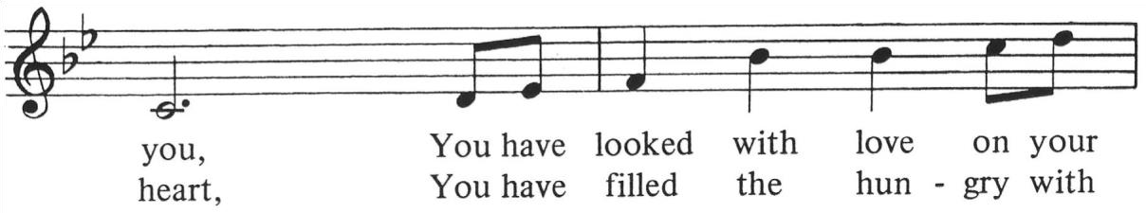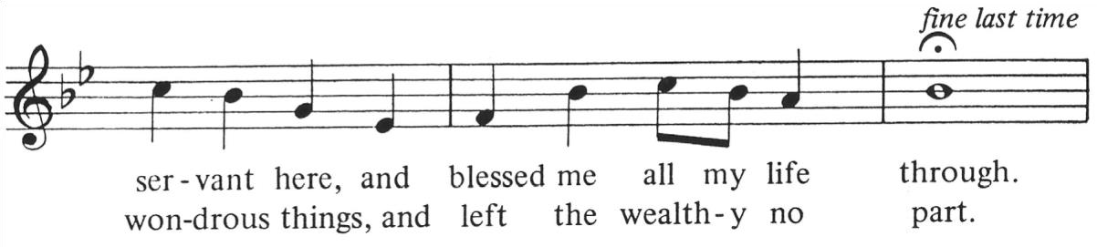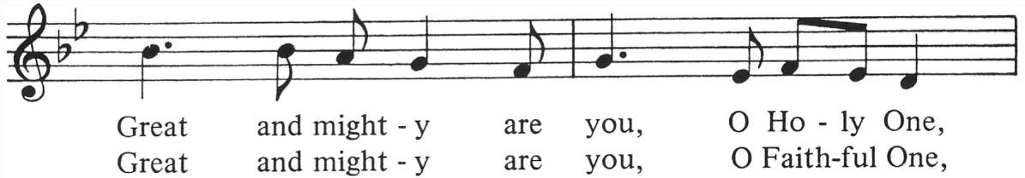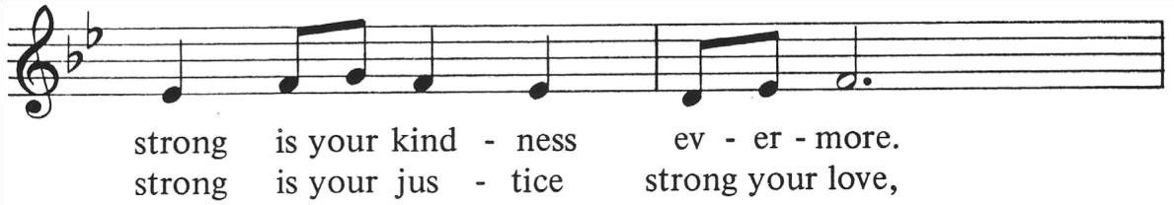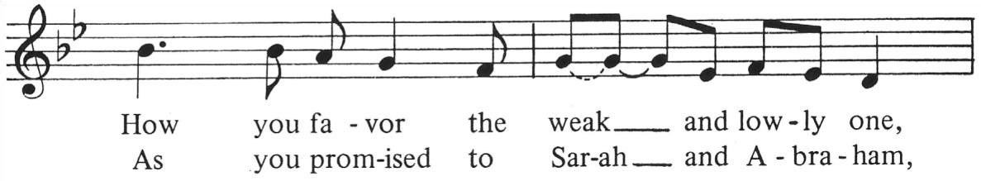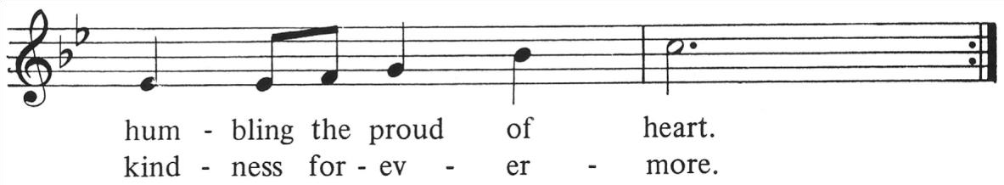

Litany and Prayers
☹ In peace, in peace, we pray to you:
 God of mercy, hold us in love.
☹ For peace and salvation, we pray to you:
 God of mercy, hold us in love.
☹ For peace between nations, for peace between peoples:  God of mercy, hold us in love.
☹ For us who are gathered to worship and praise you:  God of mercy, hold us in love.
☹ For all of your servants who live out your gospel:
 God of mercy, hold us in love.
☹ For all those who govern, that justice might guide them:  God of mercy, hold us in love.
☹ For all those who labor in service to others:  God of mercy, hold us in love.
☹ Grant weather that nourishes all of creation:
 God of mercy, hold us in love.
☹ Keep watch on our loved ones and keep us from danger:  God of mercy, hold us in love.
☹ For all the beloved who rest in your mercy:  God of mercy, hold us in love.
☹ Help us, comfort us, all of our days:
 Keep us, hold us, gracious God.
☹ Great and merciful God, Source and Ground of all goodness and life, give to your people the peace that passes all understanding, and the will to live your gospel of mercy and justice, through Jesus Christ our Lord.
 Amen.

☹ God, remember us in your love, and teach us to pray:
 Our Father in heaven, hallowed be your name. Your Kingdom come, your will be done on earth as in heaven. Give us today our daily bread. Forgive us our sins as we forgive those who sin against us. Save us from the time of trial and deliver us from evil. For the Kingdom, the power, and the glory are yours, now and forever. Amen. Final Blessing
